Remember, a thesis is…
- Interpretive of the information read
- Specific
- Has reasons/ideas embedded
Parents are regulating the amount of television their children watch because it prevents social
interaction, shortens children’s attention spans, and isn’t always intellectually stimulating.

Example 1:
Writing Situation
You are given a text set to read about athletic careers and salaries compared to low-paying, harder jobs.
Topic
Athletic careers & salaries vs. Low-paying, harder jobs

Sample Thesis (interpretative Meaning/Main Idea)
Athletes make large sums of money for entertain and publicity compared to others who must fight for minimum wage and work tirelessly in harsh conditions.

Example 2:
Topic: Endangered Animals
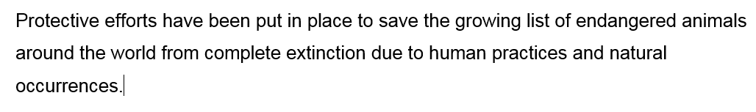
Interpretive Meaning/Main Idea:
Animals are endangered due to human practices and natural occurrences. The list is growing. People are protecting these animals.

